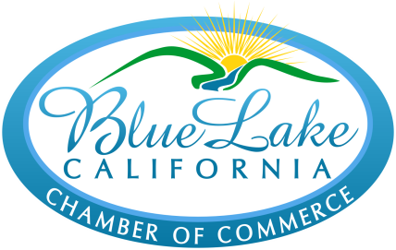
sunnybluelake.com

Annie & Mary Day Food Vendor Booth Application
(To be returned with application fee of $65)

Yes, I would like a food vendor booth for Annie & Mary Day on Sunday, July 11th, 2021!

I will sell (please specify your merchandise):

Name: _____________________________ Business Name: ________________________________________

Address: _____________________________________________ Phone: _____________________________

Email Address: _____________________________________________________________________________

If you will be cooking food onsite or will be reusing utensil and dishes and will need a washing station, please let us know, as you will need a larger site to accommodate cooking and/or dishwashing equipment. Yes __________ No __________

Before you send in this application to the Blue Lake Chamber of Commerce, please download and/or read the information provided by the Humboldt Division of Environmental Health:
humboldtgov.org/DocumentCenter/View/51814/Temporary-Food-Facility-Permit-Application-and-Policy-PDF.
You can also call Environmental Health at (707) 445-6215, or go to their office at 100 H Street in Eureka.

Note that the deadline to turn in the County application is 10 working days before Annie & Mary Day, that is, no later than June 28th. The County one-day permit cost is $67 and must be paid when turning in your permit application. The County application cost is separate from the Chamber application cost. Please note that you must carry your own insurance. The Chamber reserves the right to refuse duplicate types of food vendor applications. If this event is cancelled, the Chamber will return your booth fee of $65.00.

Please return the Annie & Mary Day application before July 8th with a $65 check made payable to: Blue Lake Chamber of Commerce
PO Box 476
Blue Lake, CA 95525

If you have any questions, please call Mariel Morison at (707) 667-6233 or email at:
mkomorison@yahoo.com

