sunnybluelake.com

PARADE PARTICIPANT APPLICATION
BLUE LAKE CHAMBER OF COMMERCE-A PROUD SPONSOR
SUNDAY, JULY 11TH, 2021
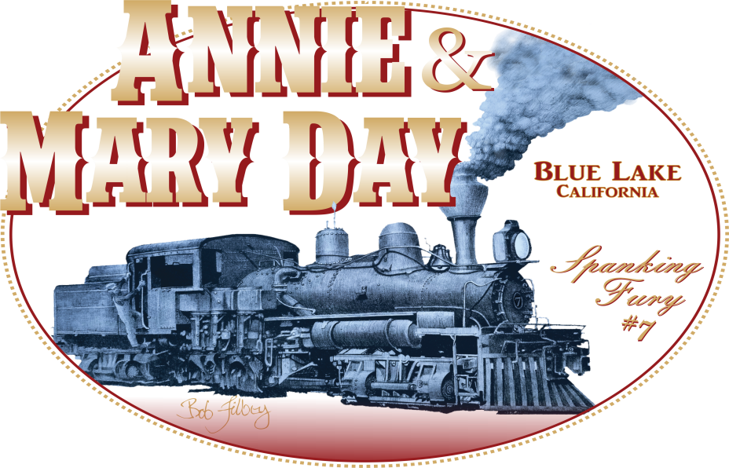

Start Time: Line-up 10am Parade Begins: 11am. Line-up will begin on Taylor Way in the Powers Creek District next to Mad River Brewery. Here are the directions to Mad River Brewery: Exit Hwy 299 onto Blue Lake Blvd. Turn RIGHT onto Greenwood Ave at Blue Lake Elementary School. Continue past City Hall following the bend LEFT onto Railroad Ave, towards Blue Lake Museum. Turn RIGHT onto Hatchery Rd. Turn RIGHT onto Taylor Way.
Participants will receive instructions on position and formation once they reach the line-up on Taylor Way.
Mail completed applications to: Blue Lake Chamber of Commerce, PO Box 476, Blue Lake, CA 95525-0476
--------------------------------------------------------------------------------------------------------------------------------------------------

Applicant: ____________________________________ Mailing Address: ______________________________

Phone Number: ___________________________ Email: ___________________________________________

Type of Entry: ______________________________________________________________________________

Signature: _____________________________________________ Date: ______________________________
By participating in this event I accept all and any liability relating to all or any loss, damages, or injury that may occur. By signing this agreement, I agree to hold Blue Lake Chamber of Commerce and the City of Blue Lake entirely free from any liabilty, including financial responsibilty for injuries or damages incurred. I also acknowledge the risks involved in this activity. I am participating voluntarily, and in doing so I forfeit all right to bring a suit against Blue Lake Chamber of Commerce and/or City of Blue Lake for any reason.

